**Make your Orientation Name Badge**

**To make your name badge, follow the instructions:**

1. Click FILE in top left and click SAVE AS and save as a NEW FILE.
2. In that new file, go to PAGE 3 enter your name in the textbox on the badge.

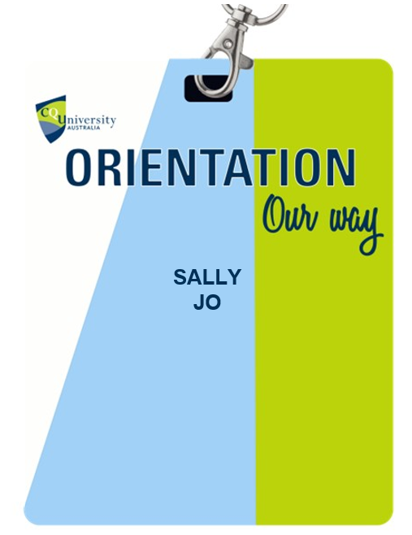

1. With the page fully visible, type “Snip & Sketch” in the Windows search bar. Open the Snip & Sketch Tool and then select “New” or press Cmd+Shift+4 on Mac to open the Screenshot app.

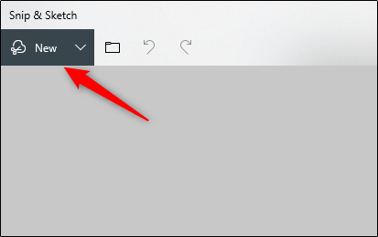

1. Crosshairs will appear on your screen. Click and drag the crosshairs to capture the name badge in the Word document.
2. Next, if you’re using Snip & Sketch on Windows, select the floppy disk icon to save the image. Mac users will select File > Export.

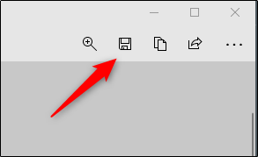

1. Give your image a name and select “JPEG” from the file type list. Finally, click “Save.”

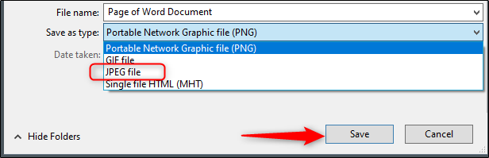

**EXTRAS:**

When you have attended or completed OTV, Countdown to Uni, Orientation Boost or Orientation Connect, you can add these badges to your name badge.

To do this, click and drag the badge you want onto the name tag.

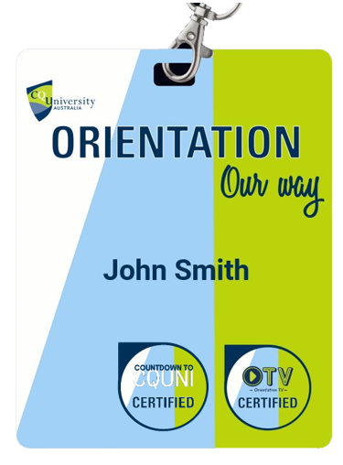

Follow step 3 to 6 to export your name badge.

Put your name badge on social media or post it in the chat function whilst in zoom session.

It is yours to use!

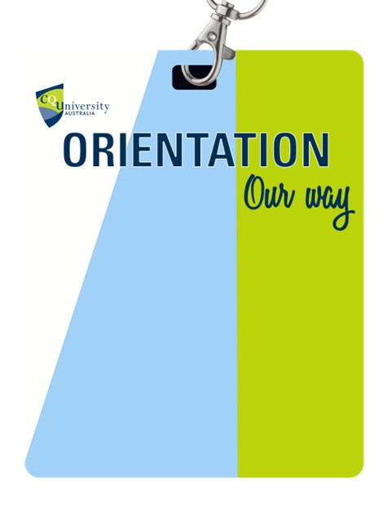

**SALLY  
JO**

